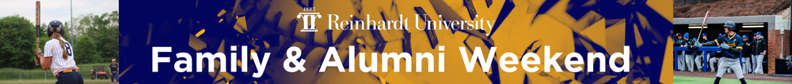

Reinhardt University welcomes families and alumni to campus for Family & Alumni Weekend!
Family & Alumni Weekend will take place April 17-19, 2026, with a variety of activities for you and your family to enjoy. Athletic and performing arts events will highlight and showcase our Eagle spirit and talent. Whether you’re returning as an alumnus or visiting as a family member, this weekend promises to be memorable and enriching. We are excited to welcome our families and alumni back to campus for a fun-filled spring weekend.

Advance Registration – Advance registration is strongly encouraged. Those who register by Wednesday, April 15 will be automatically entered into a drawing for a $50 gift card to The Landing Bookstore. Four winners will be selected. Two will be selected each day during drawings held at 4:00 p.m. on Friday, April 17, and 6:00 p.m. Saturday, April 18. Winners will be notified by phone and may claim their gift card at The Landing Tent. Must be on campus to win. Please complete the appropriate registration form below:
- Family Registration
- Alumni Registration
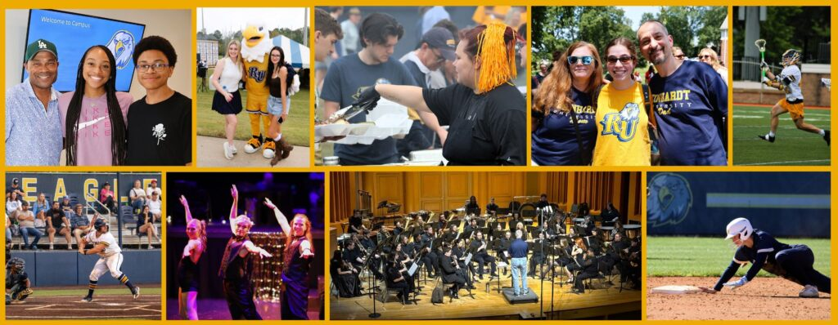
Image | Date/Time | Event | Location | Description
Friday, April 17, 2026
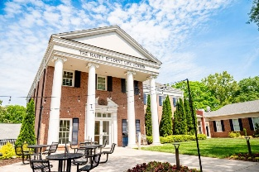 | 11:00 AM – 2:00 PM | Family & Alumni Weekend Check-in | Hasty Student Life Center | Visit the Welcome Tent which is the source for all of your Family & Alumni Weekend needs. Please check in when you arrive on campus. This is also the perfect place to meet up with your student, connect with other families, and review the action-packed schedule for this extraordinary weekend.
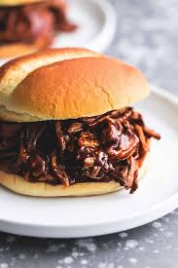 | 11:00 PM – 2:00 PM | BBQ Cookout Lunch | Lawn between Ken White Fields | Join us for a BBQ Cookout lunch while you enjoy Tailgating. Students eat free, family and alumni are $9 per person.
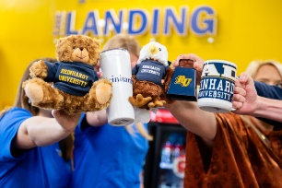 | 11:00 AM –4:00 PM | Get Your Eagle Swag | Lawn between Ken White Fields | Stop by the large gold tent, for all your alumni and spirit wear!
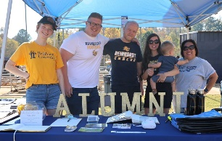 | 12:00 PM – 5:00 PM | RU Family & Alumni Weekend Tailgating | Lawn between Ken White Fields | Join the Reinhardt Community for some family fun with activities for all ages. During tailgating, you will have the opportunity to create memories, enjoy yard games, and experience Eagle traditions. Join us in supporting our athletic teams and wear your best Reinhardt Spirit!
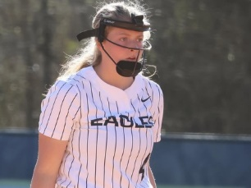 | 1:00 PM – 3:00 PM  3:00 PM – 5:00 PM | Eagles Softball | Ken White Fields | Come support Women’s Softball for their Senior Day as they take on Tennessee Wesleyan University! Go Eagles!
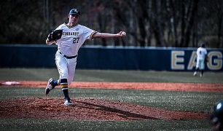 | 3:00 PM – 5:00 PM | Eagles Baseball | Ken White Fields | Come support men’s Baseball as they take on University of Pikeville! Go Eagles!
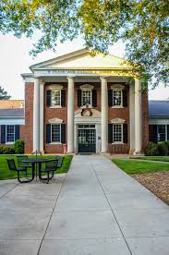 | 4:30 PM – 7:00 PM | Dinner | Gordy Dining Center | Enjoy dinner with Reinhardt students, families and alumni. Reinhardt students on a meal plan are covered, while alumni, parents, families and other guests are $9 each.
 | 7:30 PM – 9:30 PM | Musical Theatre Presents: If/Then | University Theater | Come support Reinhardt’s music theatre students as they present the musical “If/Then.” Think of all of the things you’d have done, if only you’d known. If/Then is a contemporary musical that explores the complexities of choice and chance through the life of Elizabeth, a city planner who returns to New York in search of a fresh start. As she navigates the city's possibilities of love, career, and self-discovery, a single decision splits her life into two parallel paths; Liz and Beth. If/Then follows both stories simultaneously as this modern woman faces the question; What If? Click here to learn more and to purchase tickets.
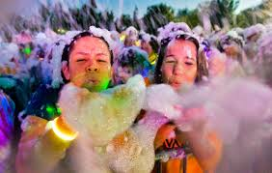 | 9:00 PM – 11:00 PM | Reinhardt After Dark: Foam Dance Party | Hasty Student Life Center | The Student Activities Council is thrilled to bring the ultimate foam party experience to Reinhardt. Get ready for an evening filled with fun, foam, and fantastic memories. The music’s booming, everyone’s laughing and dancing, and you're surrounded by soft, sudsy bubbles up to your knees. Bring your friends, get ready to dance, and dive into a sea of foam for an unforgettable night. It’s the perfect way to celebrate and create lasting memories with your fellow students. [Current Reinhardt Students Only]
Saturday, April 18, 2026
 | 11:00 AM – 2:00 PM | Family & Alumni Weekend Check-in | Hasty Student Life Center | Visit the Check-in tent which is the source for all of your Family & Alumni Weekend needs. Please check in when you arrive on campus. This is also the perfect place to meet up with your student, connect with other families, and review the action-packed schedule for this extraordinary weekend.
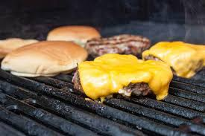 | 11:00 AM – 1:30 PM | Burger & Hotdog Cookout Lunch | Lawn between Ken White Fields | Join us for a burger and hotdog cookout lunch while you enjoy Tailgating. Students eat free, family and alumni are $9 per person.
 | 11:00 PM – 5:00 PM | RU Family & Alumni Weekend Tailgating | Lawn between Ken White Fields | Join the Reinhardt Community for some family fun with activities for all ages. During tailgating, you will have the opportunity to create memories, enjoy yard games, and experience Eagle traditions. Join us in supporting our athletic teams and wear your best Reinhardt Spirit!
 | 12:00 PM – 2:00 PM  3:00 PM – 5:00 PM | Eagles Baseball | Ken White Fields | Come support Men’s Baseball as they take on University of Pikeville! Go Eagles! Senior Day and Ring Ceremony.
 | 2:30 PM – 4:30 PM  7:30 PM – 9:30 PM | Musical Theater Presents: If/Then | University Theater | Come support Reinhardt’s music theater students as they present the musical “If/Then.” Think of all of the things you’d have done, if only you’d known. If/Then is a contemporary musical that explores the complexities of choice and chance through the life of Elizabeth, a city planner who returns to New York in search of a fresh start. As she navigates the city's possibilities of love, career, and self-discovery, a single decision splits her life into two parallel paths; Liz and Beth. If/Then follows both stories simultaneously as this modern woman faces the question; What If? Click here to learn more and to purchase tickets.
 | 4:30 PM – 6:00 PM | Dinner | Gordy Dining Center | Enjoy dinner with Reinhardt students, families and alumni. Reinhardt students on a meal plan are covered, while alumni, parents, families and other guests are $9 each.
 | 6:00 PM – 9:00 PM | Get Your Eagle Swag | Outside the Isherwood Fieldhouse | Stop by the large gold tent, for all your alumni and spirit wear!
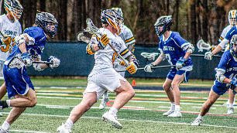 | 7:30 PM – 9:30 PM | Men’s Lacrosse | Ken White Fields | Come support Men’s Lacrosse for their Senior Night as they take on Life University! Go Eagles!
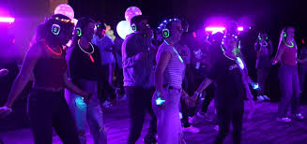 | 9:30 PM – 11:30 PM | Reinhardt After Dark – Silent Disco | Hasty Student Life Center, Bannister Glasshouse | Join the Student Activities Council for “Silent Disco” where you can groove to your favorite beats at our silent disco!  Experience an unforgettable night with music directly in your headphones, allowing you to dance the night away while enjoying stunning views. Choose your favorite DJ channel and let the music move you in a unique and immersive setting. This is a fun, low-pressure way to enjoy music, hang out, and vibe with friends. Grab a headset and hit the dance floor—no noise, just good times!  Don't miss out on this one-of-a-kind party experience! [Current Reinhardt Students Only]
Sunday, April 13, 2025
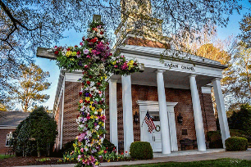 | 10:30AM-11:30AM | Worship Service | Blanche Hagan Chapel | All are welcome to worship with Waleska United Methodist Church.
 | 11:00 AM-1:30 PM | Brunch | Gordy Dining Center | Enjoy brunch and wrap up Family Alumni Weekend. Reinhardt students on a meal plan are covered, while alumni, parents, families and other guests are $9 each.
 | 2:30 PM – 4:30 PM | Musical Theatre Presents: If/Then | University Theater | Come support Reinhardt’s music theatre students as they present the musical “If/Then.” Think of all of the things you’d have done, if only you’d known. If/Then is a contemporary musical that explores the complexities of choice and chance through the life of Elizabeth, a city planner who returns to New York in search of a fresh start. As she navigates the city's possibilities of love, career, and self-discovery, a single decision splits her life into two parallel paths; Liz and Beth. If/Then follows both stories simultaneously as this modern woman faces the question; What If? Click here to learn more and to purchase tickets.
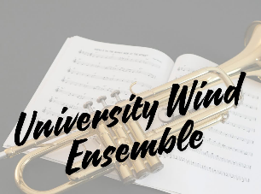 | 3:00 PM – 5:00 PM | Wind Ensemble Concert | Falany Performing Arts Center, Flint Hall | Come support Reinhardt's Wind Ensemble as they present their Free Spring concert. The University Wind Ensemble is comprised of Reinhardt student-musicians who perform the finest large ensemble and chamber music literature, including world-premiere performances from today’s most innovative and exceptional composers.

Associated Information

Accommodations – Reinhardt University suggests family, alumni and guests traveling to Waleska for Family & Alumni Weekend consider staying at local options, close to campus. Click here for a list of hotels available near Reinhardt University. All hotels listed are within 15 minutes of campus and are in Canton, Jasper and Woodstock. Please note that Reinhardt University is in no way affiliated with these hotels.

Maps and Directions to Campus – Click here for directions to campus and for parking and campus maps.

Athletic Parking – Reinhardt Eagle fans have multiple options for athletic parking for Family & Alumni Weekend. Parking is available on a first come, first served basis while supplies last. Parking availability on gamedays is not guaranteed. Parking is provided free of charge at parking lots on campus. Reinhardt students, faculty and staff are encouraged to park their vehicles on campus near the academic buildings and residence halls and to walk to the games and other activities. Other fans, family members and guests can utilize the specified parking lots in and around the Brown Athletic Center. If fans are unable to find a spot in the lots adjacent to the Brown Athletic Center, they can go to church parking lot at the Hwy 140/Hwy 108 intersection or the various parking lots throughout the campus. Handicap parking is available in the Isherwood Fieldhouse. The Isherwood Fieldhouse parking lot is for officials and handicapped spectators ONLY and tailgating is not permitted in this parking area. Parking is NOT permitted in any spot marked reserved for special permits, administrators, event workers, or game officials at any time. Violators are subject to ticketing and towing. Click here to see the campus parking map.

Athletic Facilities Entrance – There is only one entrance gate for the Boring Sports Complex which contains the Ken White Fields and the Isherwood Fieldhouse. The game day entrance is located at the bridge.

