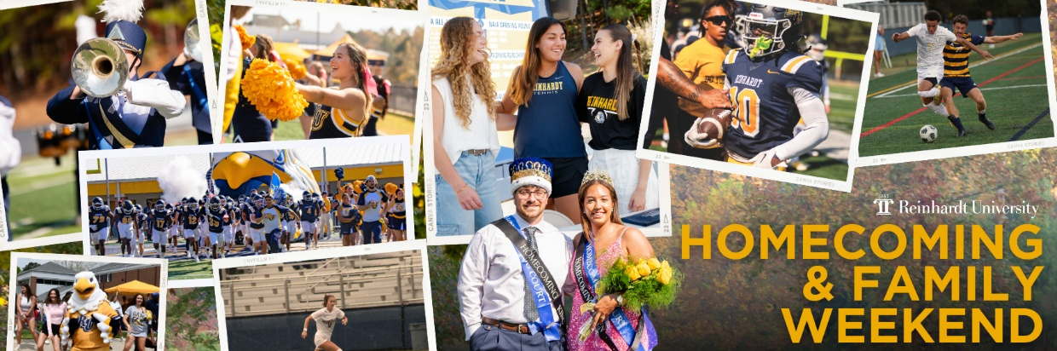
Homecoming & Family Weekend 2025
October 13-19, 2025

Calling all RU Eagles!
Join us for a fun, action packed Reinhardt Homecoming and Family Weekend! Join us in showing off your school spirit by wearing Blue and Gold to the Homecoming & Family Weekend Games!
Homecoming & Family Weekend is a cherished RU Homecoming tradition, bringing together students, their families, and alumni for a memorable weekend filled with school spirit, athletics and community. Everyone is invited to join in the festivities. We look forward to welcoming you back to campus, creating unforgettable memories, and reinforcing the sense of belonging that makes Reinhardt University a second home for students and their families.
We are excited to welcome parents and families to campus for our combined Homecoming and Family Weekend. You will have the opportunity to meet faculty, cheer on the Reinhardt teams, and most importantly—enjoy time with your student, their friends, and other Reinhardt parents.
Homecoming & Family Weekend Event Schedule
Monday, October 13th, 2025: Gold Out
Date/Time | Event | Location | Description
7:00PM-7:30PM | Pep Rally | Intramural Field, Brown Athletic Cetner | Let’s get fired up for the Homecoming & Family Week with an incredible Pep Rally that will include activities, games, Screaming Eagles Marching Band, Cheerleaders, SOAR, the Mascot, and so much more! The first 150 students will receive the Homecoming T-shirts.
7:30PM-9:30PM | Moonlight Madness | Main Gym, Brown Athletic Center | Kickoff the start of the Men’s and Women’s Basketball season with Moonlight Madness! Prize Giveaways. Dunk contest with RU celebrity judges. Skill competition.
Tuesday, October 14th, 2025: Twin Day
Date/Time | Event | Location | Description
11:00AM-1:00PM | Student Affairs Unplugged | Lawn, Hasty Student Life Center | Join the Student Affairs office during lunch for fun mini games and cool giveaways! The best dressed twins will win a special prize!
6:30 PM-8:00 PM | Reinhardt Women’s Volleyball vs. Columbia College | Main Gym, Brown Athletic Center | Come out and support Reinhardt University Women’s Volleyball team as they compete against Columbia College!
TBD | Faith & Film | Bannister Glasshouse, Hasty Student Life Center | Join Campus Ministries for a fun night of snacks and a movie! Bring your blankets and wear your slippers as you watch the movie!
Wednesday, October 15, 2025: Breast Cancer Awareness Pink Out
Date/Time | Event | Location | Description
11:00 AM - 4:00 PM | Blood Drive | Bannister Glasshouse, Hasty Student Life Center | Join the American Red Cross as they host a Blood Drive on campus! Every donation can help up to three people in need. Walk-ins are welcome, but appointments are encouraged. Come be a hero—your single act of kindness can make a world of difference!
5:00PM-7:00PM | Reinhardt Men’s Soccer Team vs. Truett McConnell College | Ken White Stadium | Come out and support Reinhardt University Men’s Soccer team as they compete against Truett McConnell!
7:00PM-9:00PM | Reinhardt Women’s Soccer vs. Truett McConnell College | Ken White Stadium | Come out and support Reinhardt University Women’s Soccer team as they compete against Truett McConnell!
Thursday, October 16th, 2025: Jersey Day
Time | Event | Location | Description
7:00PM-9:00PM | Men’s Wrestling Blue & Gold Duals (Exhibition) | Main Gym, Brown Athletic Center | Come support Men’s Wrestling as they showcase their talents! Go Eagles!
Friday, October 17th, 2025: Country Trail Ride
Time | Event | Location | Description
7:00PM-9:00PM | Homecoming Dance | Bannister Glasshouse, Hasty Student Life Center | Join the Student Activities Council and saddle up for a western-themed homecoming dance where you can don primarily plaid flannels, bandanas, cowboy hats and your best tattered jeans and boots while learning line-dancing choreography and enjoy some great music.
Saturday, October 18th, 2025: Blue Out
Time | Event | Location | Description
9:00AM-12:00PM | Admissions: Discover Reinhardt | Bannister Glasshouse, Hasty Student Life Center | Discover what life at Reinhardt University is all about! Walk the halls and experience what over a thousand students experience every day and meet the people that make the journey possible. Learn about everything Reinhardt has to offer and join us by the Football Field and feel what being at Reinhardt has to offer!
10:00 AM – 12:00 PM | Homecoming Tailgate | Greenspace between the Baseball and Softball Fields | Join us and bring your Reinhardt school spirit to tailgating prior to kickoff. Tailgating provides the opportunity to create memories, enjoy delicious food, and experience Eagle traditions. Visit with the academic schools and campus departments for a Q&A about the wide range of academic programs, social opportunities, services and resources as well as unique experiences that Reinhardt provides students in preparation for a meaningful life and productive career. Check out the list of tailgate partners:  - Reinhardt Alumni Association  - Admissions  - McCamish School of Business & Professions  - Price School of Education  - College of Humanities, Sciences & Technology  - Cauble School of Nursing & Health Sciences  - School of the Arts  - Scholars Program  - Student Activities  - Residence Life  - Prevention & Awareness  - Campus Ministries  - Vocation & Career Services  - Student Health Center  - Delta Phi Epsilon Sorority  - Zeta Tau Alpha Sorority  - Kappa Sigma Fraternity
11:00AM-1:00 PM | BBQ Lunch | Greenspace between Baseball and Softball Fields | Join us for a BBQ lunch during Homecoming Tailgating.
11:00AM-3:00PM | Visit the Landing | Outside the Isherwood Fieldhouse | Stop by the Landing Tent and get all of your Reinhardt gear as we get ready for a fun weekend cheering on your Eagles!
12:00 PM – 3:00 PM | Reinhardt Football vs. Bluefield University | Ken White Field | Come out and support Reinhardt University Football team as they compete against Bluefield University! The Homecoming Court will be presented, and the King & Queen will be crowned during Halftime, as well as a performance by the Screaming Eagles marching band and color guard.
Sunday, October 19th, 2025
Time | Event | Location | Description
10:30AM-11:30PM | Worship Service | Hagan Chapel | All are welcome to worship with Waleska United Methodist Church.
11:00AM-1:00PM | Reinhardt Women’s Soccer Team vs. Pikeville University | Ken White Field | Come out and support Reinhardt University Women’s Soccer team as they compete against Pikeville University!
11:30 AM-1:30 PM | Brunch | Gordy Dining Center | Enjoy Sunday brunch.
1:00PM-3:00PM | Reinhardt Men’s Soccer Team vs. Pikeville University | Ken White Field | Come out and support Reinhardt University Men’s Soccer team as they compete against Pikeville University!

